SUPPLY PRO – PADS & ROLLS

Hoyt Sales • PO Box 6845, Corpus Christi, TX 78466 • 361-857-0702 or 361-537-8840 (call for quote)

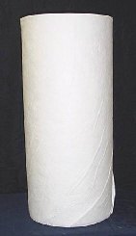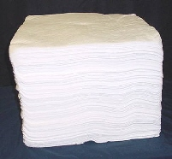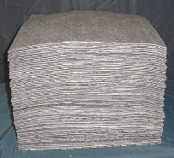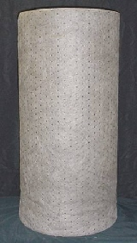

Supply Pro manufactures pads and rolls with our advanced fine fiber meltblown polypropylene technology. Longer fiber length gives our pads higher tensile strength, more durability, and greater absorption than our competitors’ standard meltblown pads. For large volume buyers, we will manufacture products customized to your specifications, and private label products upon request. Please call DISTRIBUTOR PHONE and give DISTRIBUTOR NAME the opportunity to lower your current pad and roll costs while providing you with a superior polypropylene product.

PN | Description | Dimensions |  | Count |  | Bales / Pallet
10000 | Oil Only Extra Heavy Weight Pad |  | 15” x 18” |  | 100 |  | 30
10009 | Oil Only Heavy Weight Pad |  | 15” x 18” |  | 100 |  | 30
10008 | Oil Only Heavy Weight Pad** |  | 15” x 18” |  | 100 |  | 30
10007 | Oil Only Medium Weight Pad |  | 15” x 18” |  | 100 |  | 40
10006 | Oil Only Medium Weight Pad*** |  | 15” x 18” |  | 100 |  | 40
10005 | Oil Only Light Weight Pad |  | 15” x 18” |  | 100 |  | 50
14005 | Oil Only Light Weight Pad |  | 15” x 18” |  | 200 |  | 30
13009 | Oil Only Heavy Weight Pad |  | 30” x 40” |  | 50 |  | 10
10019 | Oil Only Sprocket Bonded Heavy Weight Pad |  | 15” x 18” |  | 100 |  | 30
10017 | Oil Only Sprocket Bonded Medium Weight Pad |  | 15” x 18” |  | 100 |  | 40
20019 | Universal Sprocket Bonded Heavy Weight Pad |  | 15” x 18” |  | 100 |  | 30
20017 | Universal Sprocket Bonded Medium Weight Pad |  | 15” x 18” |  | 100 |  | 40
11009 | Oil Only Heavy Weight Roll |  | 36” x 144’ |  | 1 |  | 18
11007 | Oil Only Medium Weight Roll |  | 36” x 144’ |  | 1 |  | 18
11019 | Oil Only Sprocket Bonded Heavy Weight Roll |  | 36” x 144’ |  | 1 |  | 18
11017 | Oil Only Sprocket Bonded Medium Weight Roll |  | 36” x 144’ |  | 1 |  | 18
21019 | Universal Sprocket Bonded Heavy Weight Roll |  | 36” x 144’ |  | 1 |  | 18
21017 | Universal Sprocket Bonded Medium Weight Roll |  | 36” x 144’ |  | 1 |  | 18

** Heavy Weight according to many of our competitors who make an 8 ounce per square yard product
*** Med. Weight according to many of our competitors who make a 6-6.5 ounce per square yard product

Meltblown Polypropylene Pads and Rolls

SUPPLY PRO – PRO BOOM SERIES

Hoyt Sales • PO Box 6845, Corpus Christi, TX 78466 • 361-857-0702 or 361-537-8840 (call for quote)

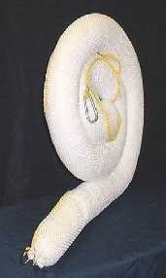

PN | Description | Booms / Bale | Weight | Bales / Pallet
B510 | 5” x 10’ Sock and Net Oil Only Boom | 4 | 20-21 lbs. | 24
B520 | 5” x 20’ Sock and Net Oil Only Boom | 2 | 20-21 lbs. | 24
B810 | 8” x 10’ Sock and Net Oil Only Boom | 4 | 40-42 lbs. | 16
B820 | 8” x 20’ Sock and Net Oil Only Boom | 2 | 40-42 lbs. | 16
SPBB518-20 | 5” x 18” Sock & Net Oil Only Bilge Boom | 20 | 15-16 lbs. | 24
SPBB818-10 | 8” x 18” Sock & Net Oil Only Bilge Boom | 10 | 15-16 lbs. | 24

SUPPLY PRO – PRO OIL SWEEP
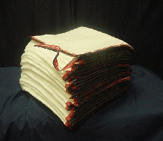

PN | Description | Weight | Sweeps / Pallet
SP1800 | 19” x 100’ x 3/8” Oil Only Meltblown Sonic Bonded Sweep | 12 lbs. | 36

PRO KNIT SOCKS & PILLOWS

Hoyt Sales • PO Box 6845, Corpus Christi, TX 78466 • 361-857-0702 or 361-537-8840 (call for quote)

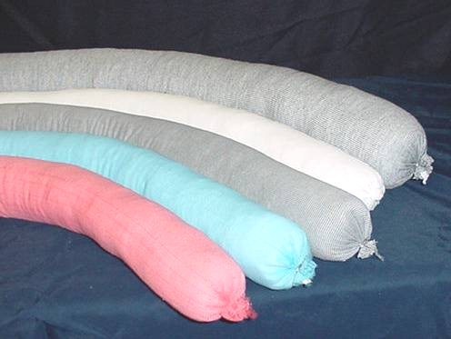

PN | Description | Socks / Case | Weight | Cases / Pallet
SPS348O | 3” x 48” White Oil Only Polypropylene | 40 | 40 lbs. | 18
SPS396O | 3” x 96” White Oil Only Polypropylene | 20 | 40 lbs. | 18
SPS3120O | 3” x 120” White Oil Only Polypropylene | 15 | 38 lbs. | 18
SPS3144O | 3” x 144” White Oil Only Polypropylene | 12 | 36 lbs. | 18
SPS348U | 3” x 48” Gray Universal Polypropylene | 40 | 40 lbs. | 18
SPS396U | 3” x 96” Gray Universal Polypropylene | 20 | 40 lbs. | 18
SPS3120U | 3” x 120” Gray Universal Polypropylene | 15 | 38 lbs. | 18
SPS3144U | 3” x 144” Gray Universal Polypropylene | 12 | 36 lbs. | 18
SPS348U | 3” x 48” Yellow Hazmat Polypropylene | 40 | 40 lbs. | 18
SPS348WF | 3” x 48” Red General Purpose Cellulose | 40 | 40 lbs. | 18
SPS396WF | 3” x 96” Red General Purpose Cellulose | 20 | 40 lbs. | 18
SPS3120WF | 3” x 120” Red General Purpose Cellulose | 15 | 38 lbs. | 18

Supply Pro, Inc. Pro Knit Socks are available for your oil only, universal, or hazmat applications. Color coded for easy identification Pro Knit Socks are filled with precise consistency lessening the likelihood of liquid leak through. A typical case of 40 four foot socks weighs 40 pounds. Pro Knit Socks absorb faster and perform with durability in the work place. Supply Pro can custom manufacture socks in your choice of length and color.

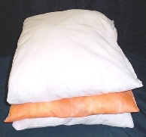

PN | Description | Pillows / Case | Cases / Pallet
SPIL918 | 9”x 18” x 2” Oil Only Pillows | 40 | 18
SPIL1010 | 10”x 10” x 2” Oil Only Pillows | 40 | 18
SPIL1818 | 18”x 18” x 2” Oil Only Pillows | 10 | 18
SPILU918 | 9”x 18” x 2” Universal Pillows | 40 | 18
SPILU1010 | 10”x 10” x 2” Universal Pillows | 40 | 18
SPILU1818 | 18”x 18” x 2” Universal Pillows | 10 | 18

Supply Pro, Inc. Pro Absorbent Pillows are available for your oil only, universal, or hazmat applications. Pro Absorbent Pillows absorb faster and perform with durability in the work place.

BAGS, TRUCK LINERS & POLY SHEETING

Hoyt Sales • PO Box 6845, Corpus Christi, TX 78466 • 361-857-0702 or 361-537-8840 (call for quote)

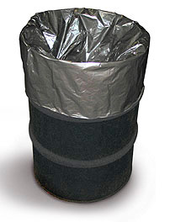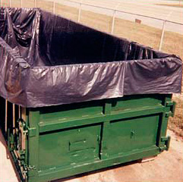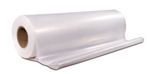

Roll Off Box & End Dump Liners

Easy Slide roll off box and end dump liners are manufactured with durable low density polyethylene. Slip and anti-block additives ensure easy slide performance. Stop wasting time at the dump and keep your drivers on the road. Call DISTRIBUTOR PHONE and let DISTRIBUTOR NAME cut your cost on liners.

PN | Description | Liners / Pallet
PS2050.3B | End Dump Trailer Liner - 20’ x 50’ x 3 mil (Black) | 50
PS1842.3B | End Dump Trailer Liner - 18’ x 42’ x 3 mil (Black) | 75
PS2030.3B | Roll Off Box Liner (20 & 30 CY) - 20’ x 30’ x 3 mil (Black) | 75
RL22 | Roll Off Box Liner (20 & 30 CY) - 8’ x 8’ x 22’ x 3 mil (Black) | 75

Poly Sheeting (Construction Wrap)

Poly sheeting is available upon request in a multitude of sizes and in your choice of clear or black. Save money with Supply Pro’s Super Strength alternative. Please call us for a quote.

PN | Description | Rolls / Pallet
PS3-20 | Poly Sheeting (Clear) 20’ x 100’ x 3 mil | 30
PS6-20 | Poly Sheeting (Clear) 20’ x 100’ x 6 mil | 25
RR300 | Super Strength Poly Sheeting 20’ x 100’ (6 mil equivalent) | 30
RR600 | Super Strength Poly Sheeting 20’ x 100’ (10 mil equivalent) | 25

Poly Bags & Stock Drum Liners

Supply Pro, Inc. is one of the largest distributors of poly bags and poly sheeting in the state of Texas. High volume purchasing equates to buying power in the commodities market, and we pass the savings on to our customers. Supply Pro has always, and will continue to set the mark when it comes to competitive pricing on poly bags and poly sheeting.

PN | Description | Bags / Roll | Rolls / Pallet
L216-PLAIN | 38” x 60” x 6 mil Clear LDPE | 50 | 30
HH3863.3 | 38” x 63” Super Strength – (replaces 4 mil LDPE) | 50 | 30
HH3863.6 | 38” x 63” Super Strength – (replaces 6 mil LDPE) | 50 | 30

SUPPLY PRO – SPILL KITS

Hoyt Sales • PO Box 6845, Corpus Christi, TX 78466 • 361-857-0702 or 361-537-8840 (call for quote)

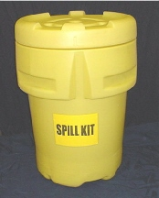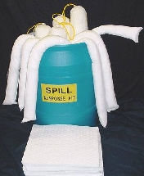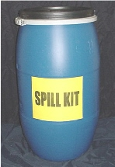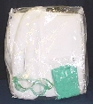

95 Gallon 55 Gallon 30 Gallon Truck

Features / Benefits

Spill kits are available as “oil only” kits (O), universal (U), or hazmat (HM)
Drum Specifications – All 95 gallon over pack drums are United Nations certified to HM-181
Compliance – All 95 gallon over pack drums are DOT 49 CFR 173.25 compliant
Absorbs up to 25 times its weight
Quick wicking speed
Superior retention
Low ash content
Dustless
Machine friendly

Spill Kit Contents

95 Gallon Kit: 95 gallon overpack drum (1) 18" x 18" pillows (10) goggles (2)
(SPILL-95O) 15" x 18" absorbent pads (100) bags and ties (10) pair gloves (2)
(SPILL-95HM) 5" x 10' non shed boom (4)

55 Gallon Kit: 55 gallon ring lock drum (1) 18" x 18" pillows (6) goggles (2)
(SPILL-55O) 15" x 18" absorbent pads (50) bags and ties (5) pair gloves (2)
(SPILL-55HM) 3" x 48" socks (12)

30 Gallon Kit: 30 gallon ring lock drum (1) 18" x 18" pillows (4) goggles (1)
(SPILL-30O) 15" x 18" absorbent pads (50) bag and tie (1) pair gloves (1)
(SPILL-30HM) 3" x 48" socks (6)

Truck Kit: vinyl zipper bag (1) 3" x 48" socks (2)
(SPK-O & SPK-U) 15" x 18" absorbent pads (15) bag and tie (1)

